12.6: a) Taking force components to be positive to the right, use of Eq. (12.1) twice gives

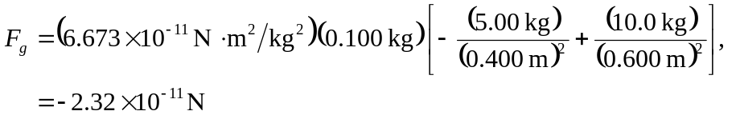
with the minus sign indicating a net force to the left.

b) No, the force found in part (a) is the net force due to the other two spheres.

